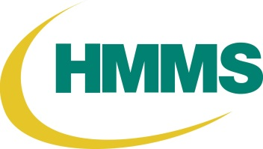

**Employee Electronic Funds Transfer (EFT) Authorization Form**

I hereby consent and give to Healthcare Materials Management Services (HMMS) the authorization to use the attached banking information to process all non-payroll reimbursements directly to my bank account through the use of Electronic Funds Transfer. I understand this information will be kept confidential and not used for any other purpose**.**

**I also agree to inform HMMS immediately should any of this information change by submitting a new Authorization Form. Please print clearly. Please fill in all areas, any incomplete forms will be returned to sender.**

|  |  |  |  |  |
| --- | --- | --- | --- | --- |
|  |  |  | |  |
| Name |
|  |  |  |  |  |
| Physician |
| Title/Position |  |
|  | LHSC Employee |
|  |
| Phone Number with Extension | St. Joseph’s Employee |
|  |  |
| MHA Employee |
| Email Address for Remittance Notification |  |
|  |  |
|  |  | |  |
| Department Name |
|  |  | | |
| Hospital Site | Room Number | | |
|  |  | | |
| Signature | Date | | |

**For security purposes you must include ONE of the following with this form:**

**A)    Attach Voided Cheque**

**B)    Attach Direct Deposit/Debit form from Bank**

*PLEASE RETURN COMPLETED FORM TO:*

**HMMS, 188 STRONACH CRESCENT, LONDON, ONTARIO N5V 3A1 ATTENTION: HMMS System Support Team**

**This personal information is collected under the authority of the Public Hospitals Act R.S.0 1990, c. P.40. and is used for expense reimbursement directly to your bank account.**